Chapter 7a + 8 Checkpoints

single and multidimensional arrays

**November 13, 2019**

**Thomas Short**

**Cis 260**

**Sc4**

**7.7.1** **The previous code swaps the first and last elements with one another twice.**

int[] list = {1, 2, 3, 5, 4};

For(int I = 0; j = list.length – 1; I < list.length **/ 2**; i++; j--)

{

Int temp = list[i];

List[i] = list[j];

List[j] = temp;

}

**7.10.2**

Key = 10

**Low mid high**

**[0]** [1] [2] [3] [4] [5] **[6]** [7] [8] [9] [10] [11] **[12]**

|  |
| --- |
| **2** 4 7 10 11 45 **50**  59 60 66 69 70 **79** |

**Low**  **mid**  **high**  5/2 is 2

**[0]** [1] **[2]** [3] [4] **[5]**

|  |
| --- |
| **2**  4  **7** 10 11 **45** |

**Low mid high**

**[3] [4] [5]**

|  |
| --- |
| **10 11 45** |

**Low mid high**

**[3] [3] [3]**

|  |
| --- |
| **10 10 10** |

Returns **[3]**

Key = 12

**Low**  **mid** **high**

**[0]** [1] [2] [3] [4] [5] **[6]** [7] [8] [9] [10] [11] **[12]**

|  |
| --- |
| **2**  4 7 10 11 45 **50**  59 60 66 69 70 **79** |

**Low**  **mid**  **high**

**[0]** [1] **[2]** [3] [4] **[5]**

|  |
| --- |
| **2**  4 **7** 10 11  **45** |

**Low mid high**

**[3] [4] [5]**

|  |
| --- |
| **10**  **11**  **45** |

**Low mid high**

**[5] [5] [5]**

|  |
| --- |
| **45 45 45** |

**Low high**

**[5] [4]**

|  |
| --- |
| **45 11** |

Returns  **[-6]**

**7.11.1** Selection Sort

Swap

|  |
| --- |
| **3.4** 5 3 3.5 2.2 **1.9** 2 |

swap

|  |
| --- |
| 1.9  **5** 3 3.5 2.2 3.4  **2** |

swap

|  |
| --- |
| 1.9 2 **3**  3.5 **2.2** 3.4 5 |

Swap

|  |
| --- |
| 1.9 2 2.2 **3.5** 3 **3.4** 5 |

swap

|  |
| --- |
| 1.9 2 2.2 3 **3.5** **3.4** 5 |

**sorted**

|  |
| --- |
| **1.9 2.0 2.2 3.0 3.4 3.5 5.0** |

**8.2.4** Which of the following statements are valid?

Int[ ][ ] r = new int [2]; missing[] **Invalid**

Int[ ] x = new int[]; missing size **Invalid**

Int[ ][ ] y = new int [3][ ]; **Valid**

Int[ ][ ] z = {{1,2}}; **Valid**

Int[ ][ ] m = {{1,2},{2,3}}; **Valid**

Int[ ][ ] n = {{1,2},{2,3},}; remove last, **Invalid**

**8.3.1** Show the output of the following code:

int[ ][ ] array = {{1, 2}, {3, 4}, {5, 6}};

for (int i = array.length - 1; i >= 0; i--) {

for (int j = array[i].length - 1; j >= 0; j--)

System.out.print(array[i][j] + " ");

System.out.println();

**65**

**43**

**21**

**8.8.2**

Assume char[][][] x = new char[12][5][2], how many elements are in the array? What are x.length, x[2].length, and x[0][0].length?

There are **120** elements in this array**,** x.length is **12,** x[2].length **is 5** andx[0][0].length is **2**

Programming Exercises

**Sorted? Result:**

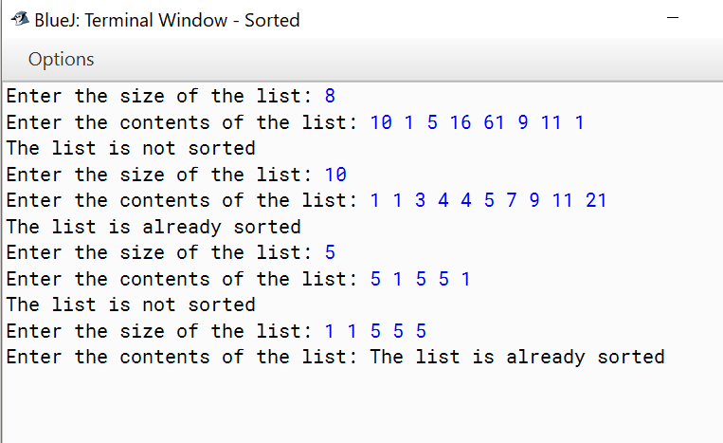

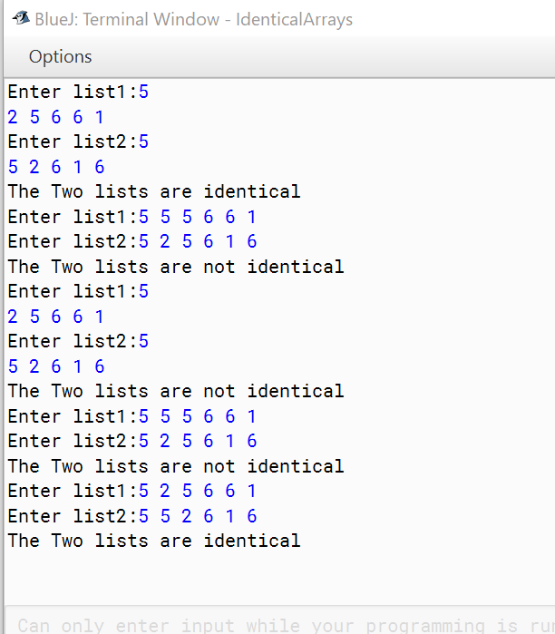**Identical Arrays Result:**

**Sort Students on Grades Result:**

